**LIBRARY MANAGEMENT SYSTEM**

PROJECT REPORT

***By***

**AMAN KUMAR**

Reg No: 12113674

Section: K21YB

Roll Number: 11

**AVIJEET SINGH BHATI**

Reg No: 12111692

Section: K21YB

Roll Number: 30

**LAVIKANT DHARIYA**

Reg No: 12105083

Section: K21YB

Roll Number: 62

## School of Computer Science Engineering

**Lovely Professional University, Jalandhar November-2022**

**INTRODUCTION TO THE PROJECT**

Library Management system is an application that enables users to create and store book records. The application provides the facilities of: issuing, returning books, editing, adding, deleting, viewing book records.

Every library needs a system that keeps track of its books and borrowers while monitoring their availability. This application is simple to understand and can be used by anyone even if they are not familiar with it. It is user friendly and just asks the user to follow step by step operations by giving them few options. It is fast and capable to keep up with a fully functioning library of any kind; like a school, university, national or special library.

The potent coding tools of PYTHON were used to create this software package. The app has excellent usability. The package includes various modules as discussed further. User input will be taken into account for future package development or improvement.

**BACKGROUND AND OBJECTIVES OF THE PROJECT:**

**Project assigned:** LIBRARY MANAGEMENT SYSTEM

**Members:** Aman Kumar, Avijeet Singh Bhati

**Background:** The project was done using the programming languages Python, MySQL, Tkinter (built-in python library)

**Objective:** To develop a programme that serves as an admins-only interface for a working library. The borrower will find it easier to receive books as a result, and it will also be more handy and appealing.

**Concrete Goals:** Connecting database to the GUI programming to obtain a project like a library management system.

**Project outcomes:** One can manage and modify book data like Book ID, name, availability, price, edition, issuance date, and return date in our Library Management System project. We can add new books to the database and update old records. If the database is larger, we can search for a record to acquire more information. We can also delete a record of unnecessary books. Finally, we can get a complete overview of the database by clicking the "Show Books" button. Simply put, we can easily control all of a book's essential details. The first and most crucial methodology is that we have a login system that allows administrators to access the database with secured information about books and borrowing records by using their MySQL login credentials.

**Most significantly, it is assumed that administrators and students have been registered already.**

**DESCRIPTION OF PROJECT:**

* Library Management System, we should take details of the books and store it into a particular database to have access over them.
* We need a user interface application or GUI for operating the commands and functions that connecting to the database to manipulate and manage data.
* We need a login system to secure the data or to get accessed by only limited members or admins.
* Methods that are necessary for managing and modifying data should be included.
* **Methods like:**
  + Adding a new book’s data
  + Updating existing records
  + Searching existing records
  + Deleting a book’s details in case it is unwanted
  + Fetching records from the database
  + Showing the records on the console according to the function used
  + Login system to connect database and to secure data
  + Added time and date of a record
  + Authenticate users at their login.
  + Provide the list of books the users can borrow.
  + Mechanism to reset the password in case user forgets it.
  + Providing interface to add or delete books to staffs.

**IMPLEMENTATION OF SCHEDULED WORK OF PROJECT**

**Output and UI of the project:**

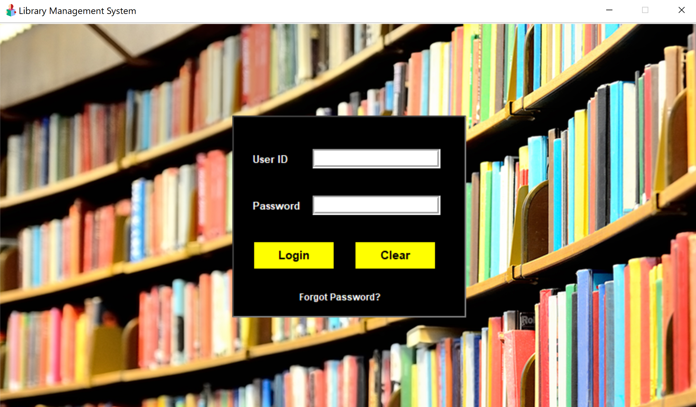

* When we click on the login button, if the credentials are valid, we will proceed to view the homepage of our application. Else a pop-up box will show “Your ID or Password is invalid!”.
* Clear button will delete all the details entered by the user in user id and password boxes till that time.
* Forgot Password button will prompt a user to enter their username and create a new password.

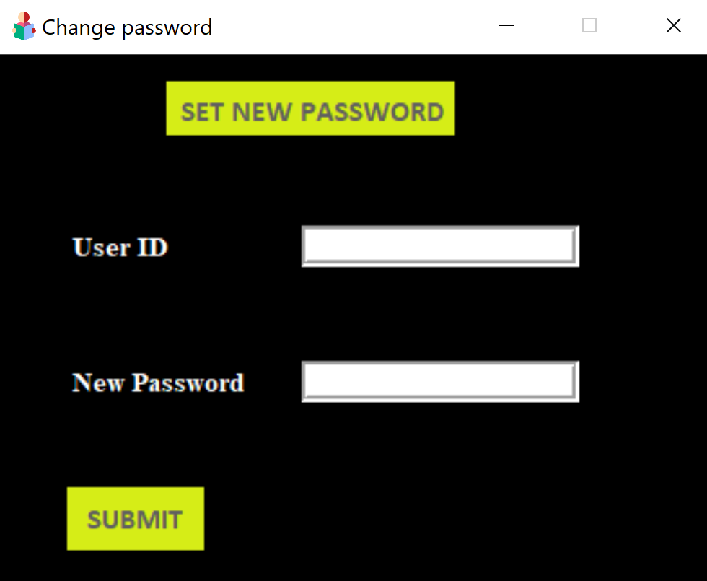

**DASHBOARD:**

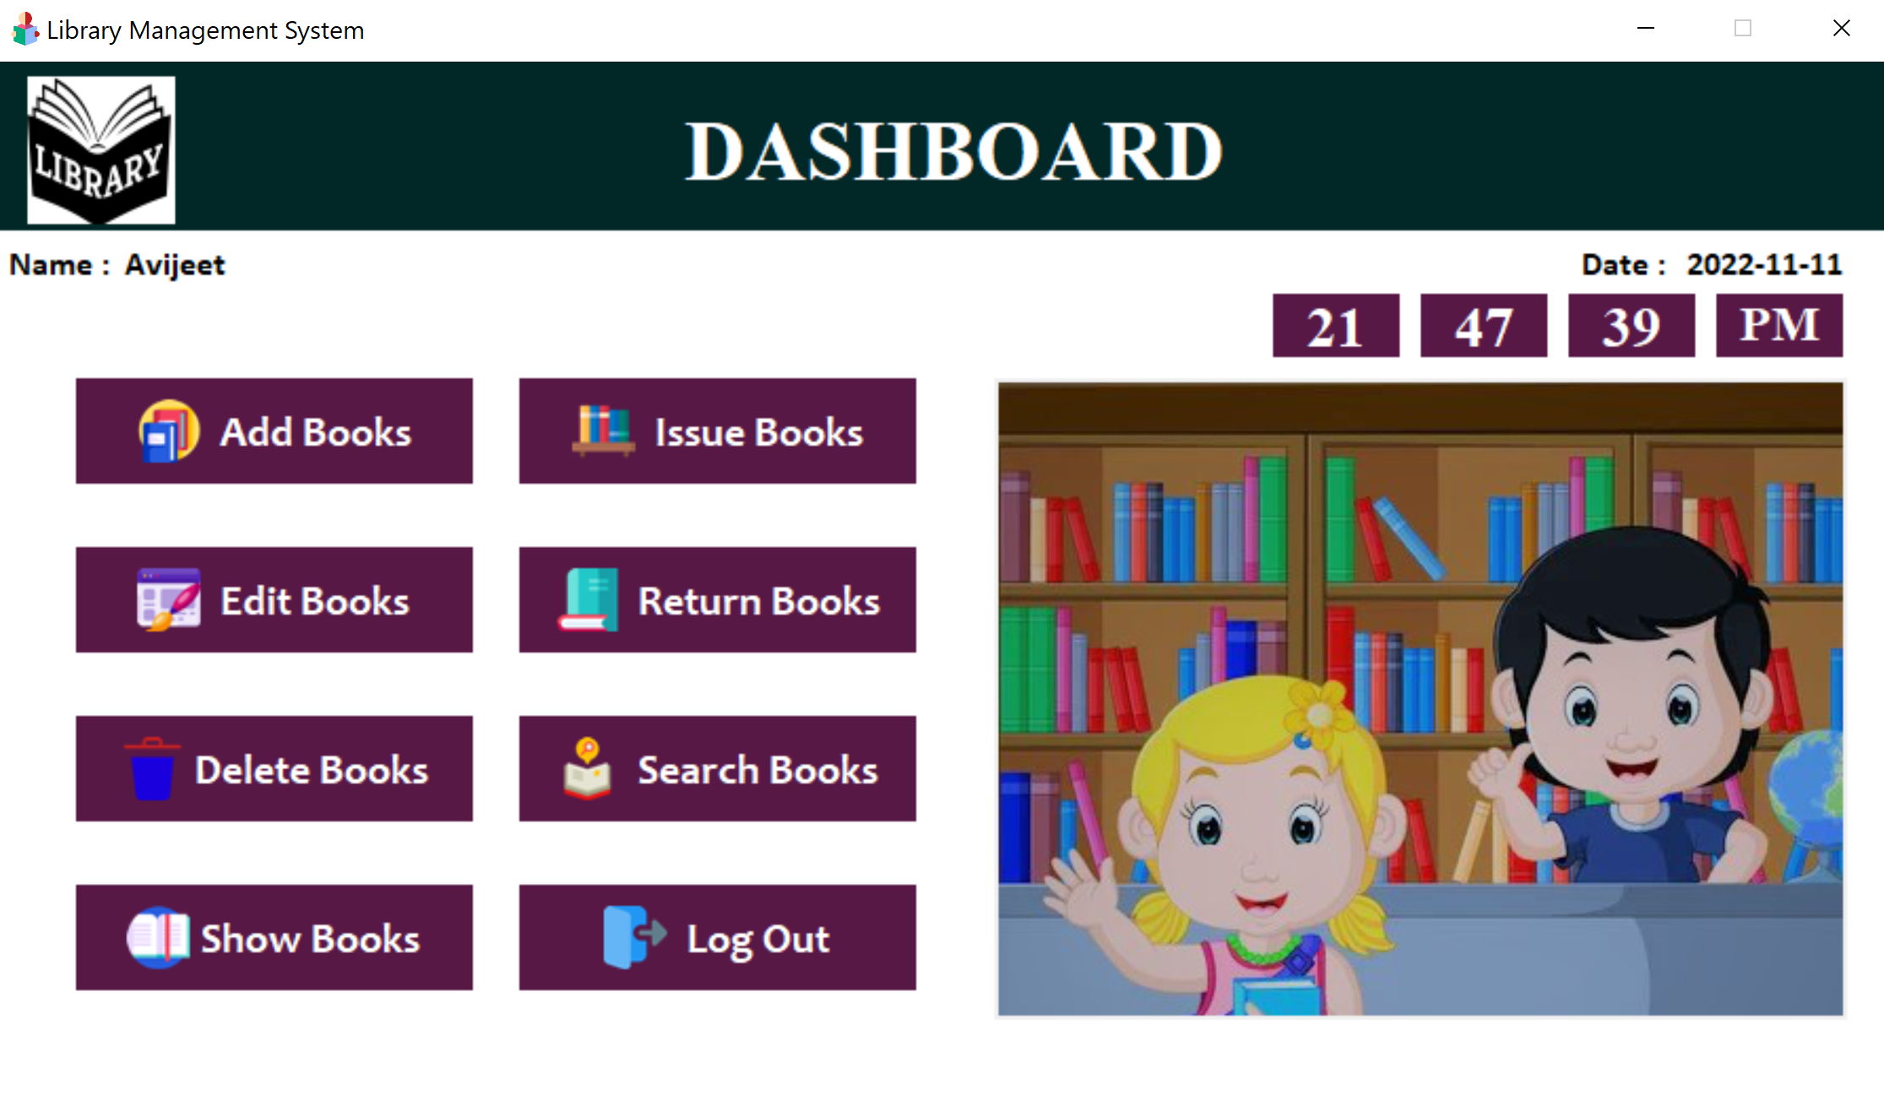

1. **ADD BOOKS**

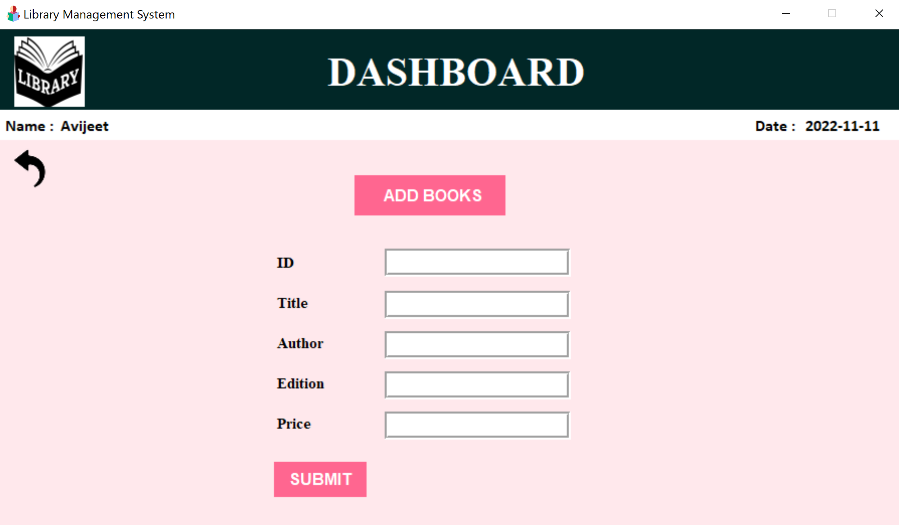

* When we click on Add Books this window will open.
* Here no field can be kept null. ID will be used as the primary key.
* ID and Price accept Integer data values, the rest Char.
* If instructions are not followed, a pop-up stating “Enter valid details” will come.

1. **ISSUE BOOKS**

* After we click on Issue Books this window will open.

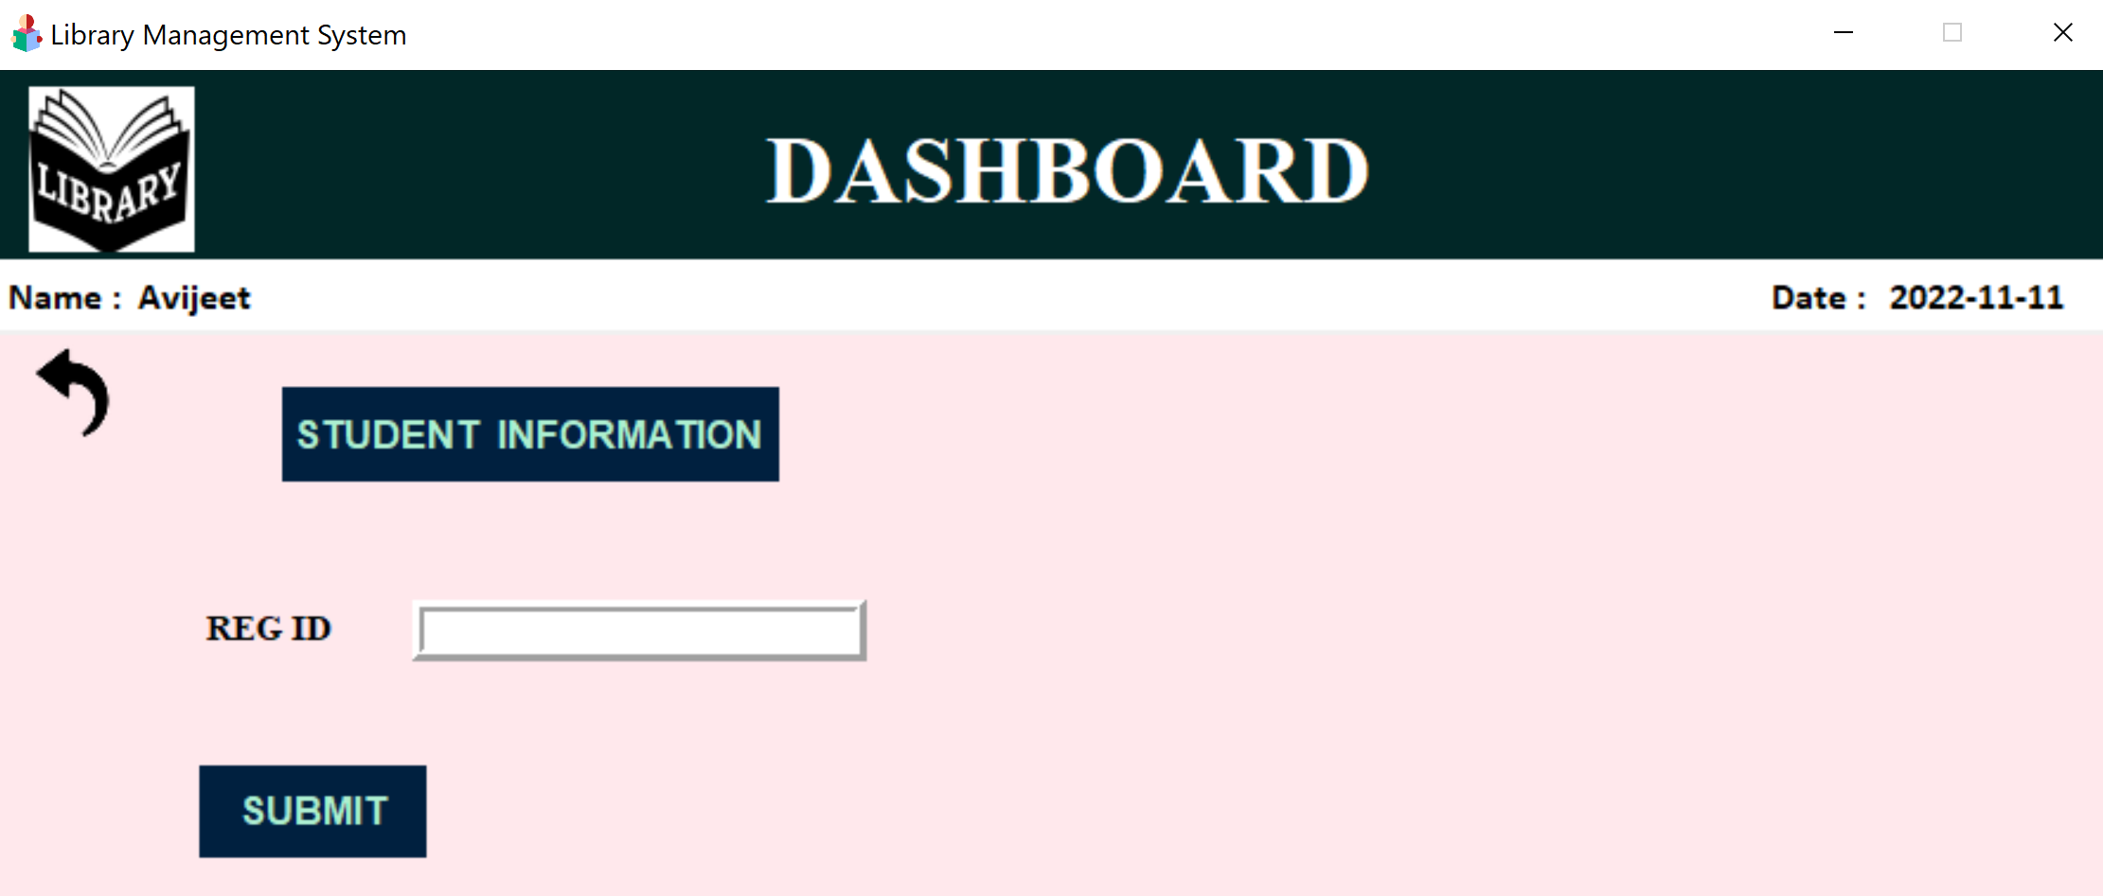

* After entering a valid Reg Id,

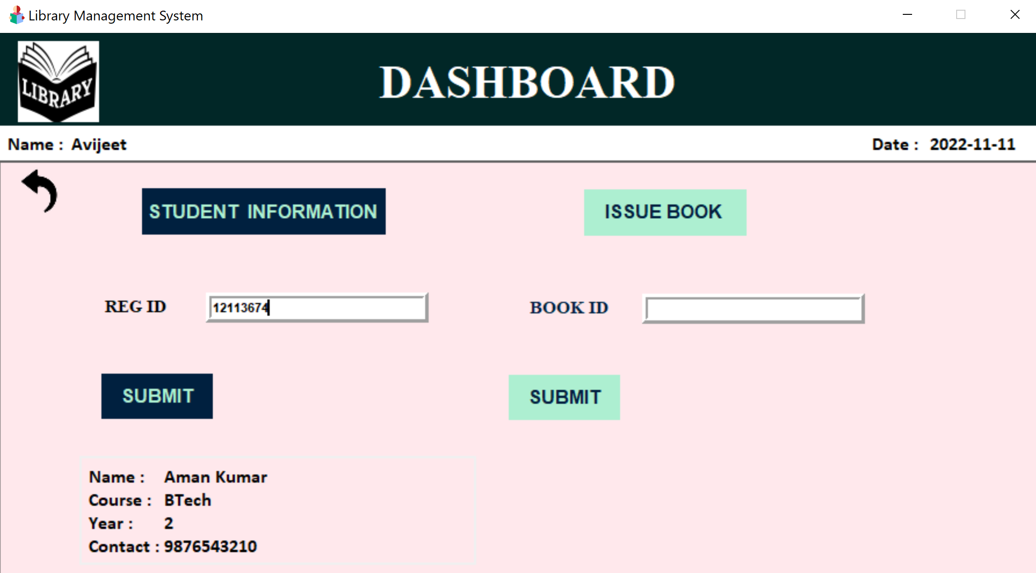

* After entering a valid book id, a new pop-up will appear asking us to select the date when the borrower wishes to return the book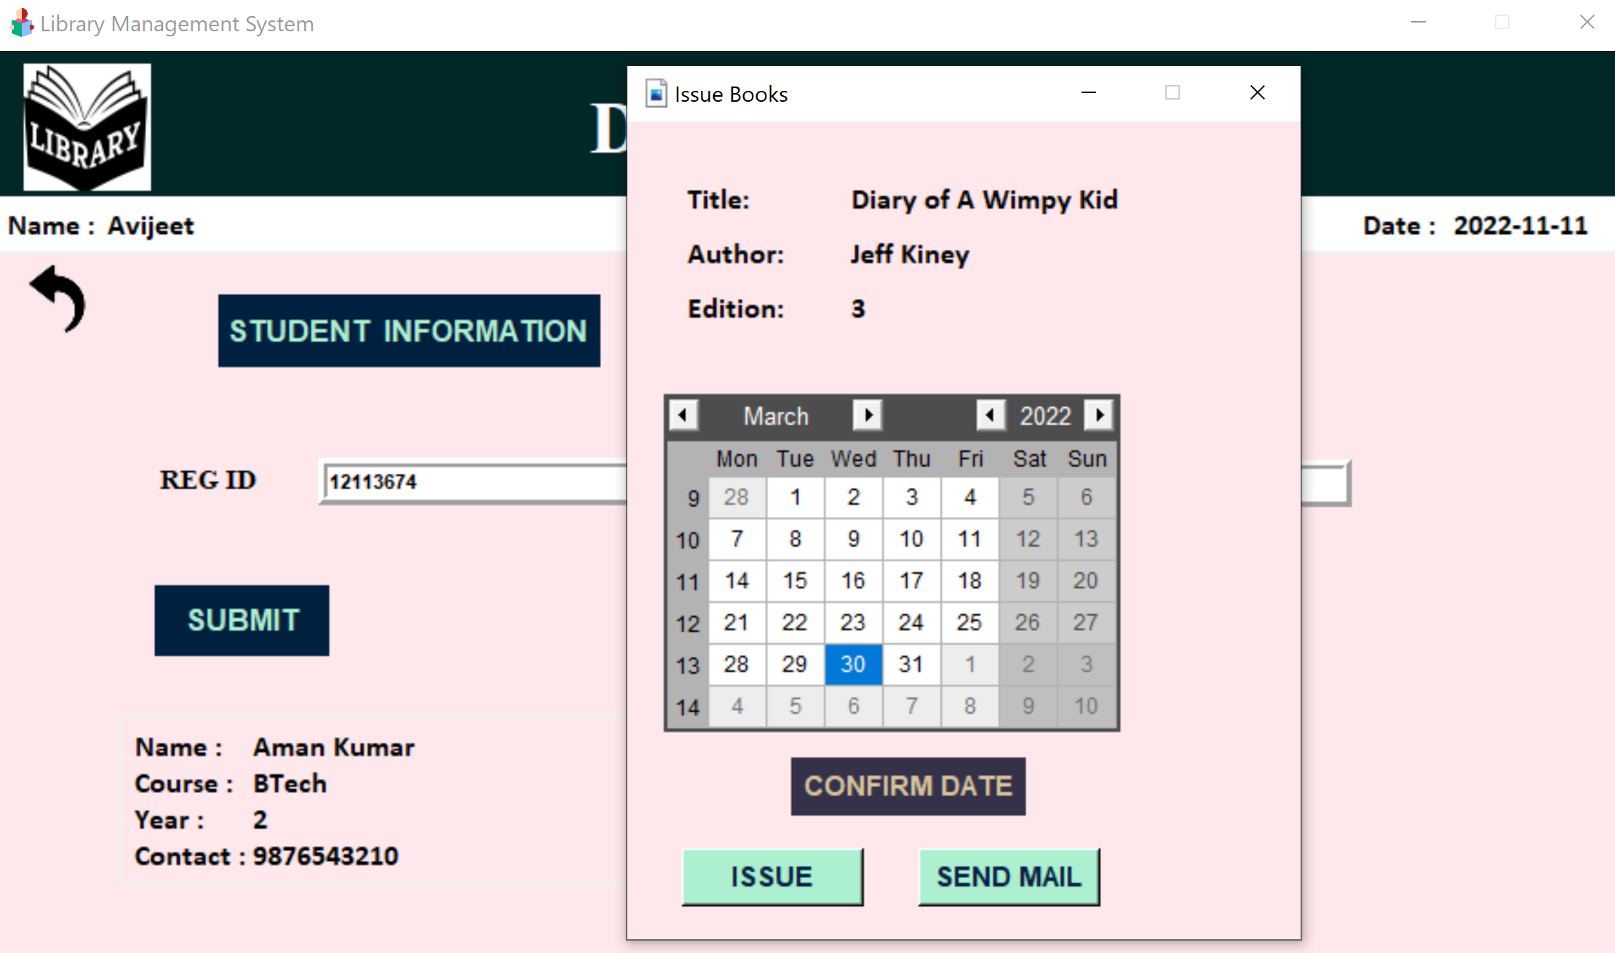
* After selecting the return date, the book has been issued.

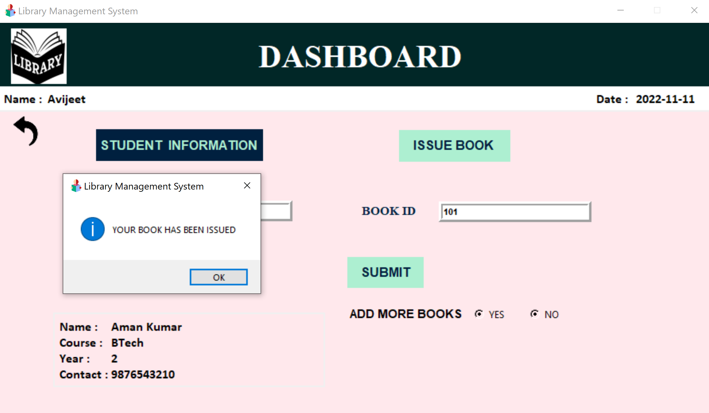

1. **EDIT BOOKS**

* After clicking the edit books button,

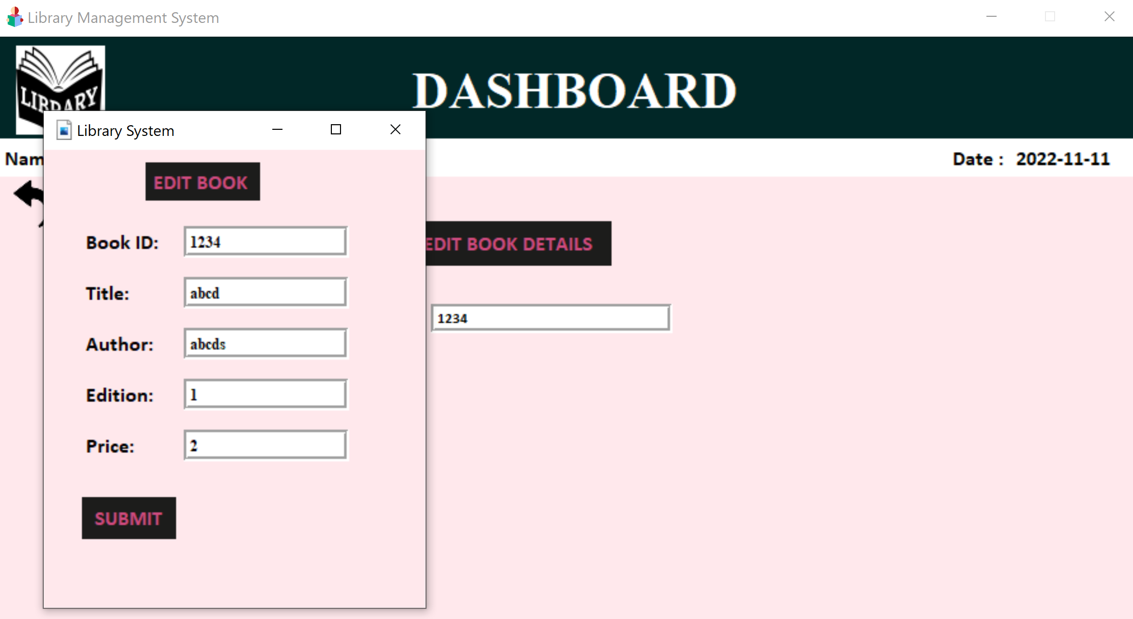

* After Clicking Submit button, (only if fields are filled according to correct data types)

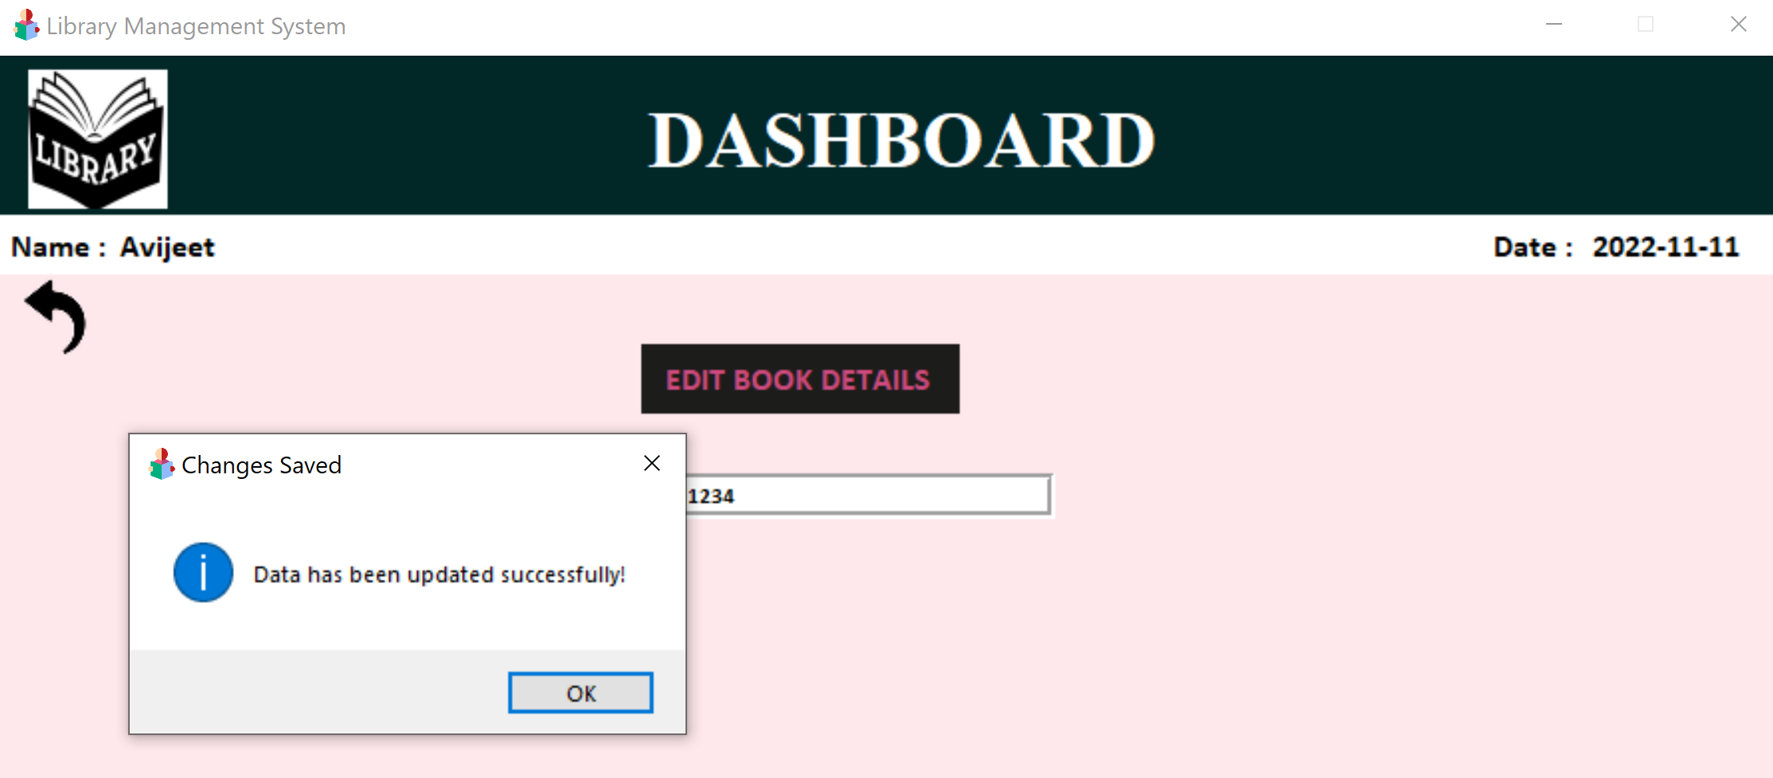

1. **RETURN BOOKS**

* After clicking Return Books;

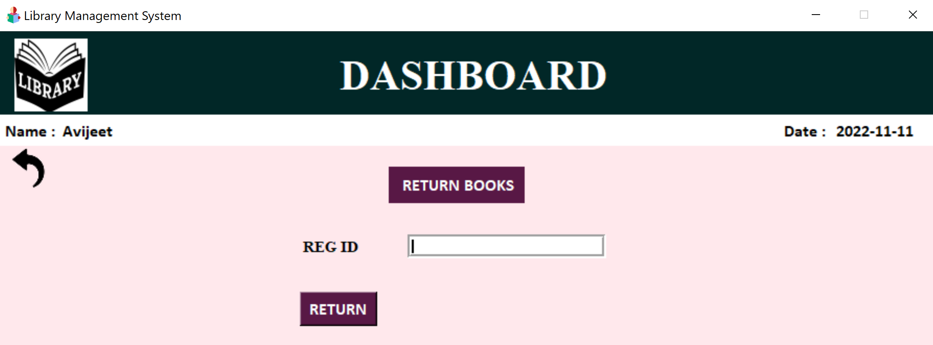

* After entering valid reg id, the book will be returned and the following screen will be shown

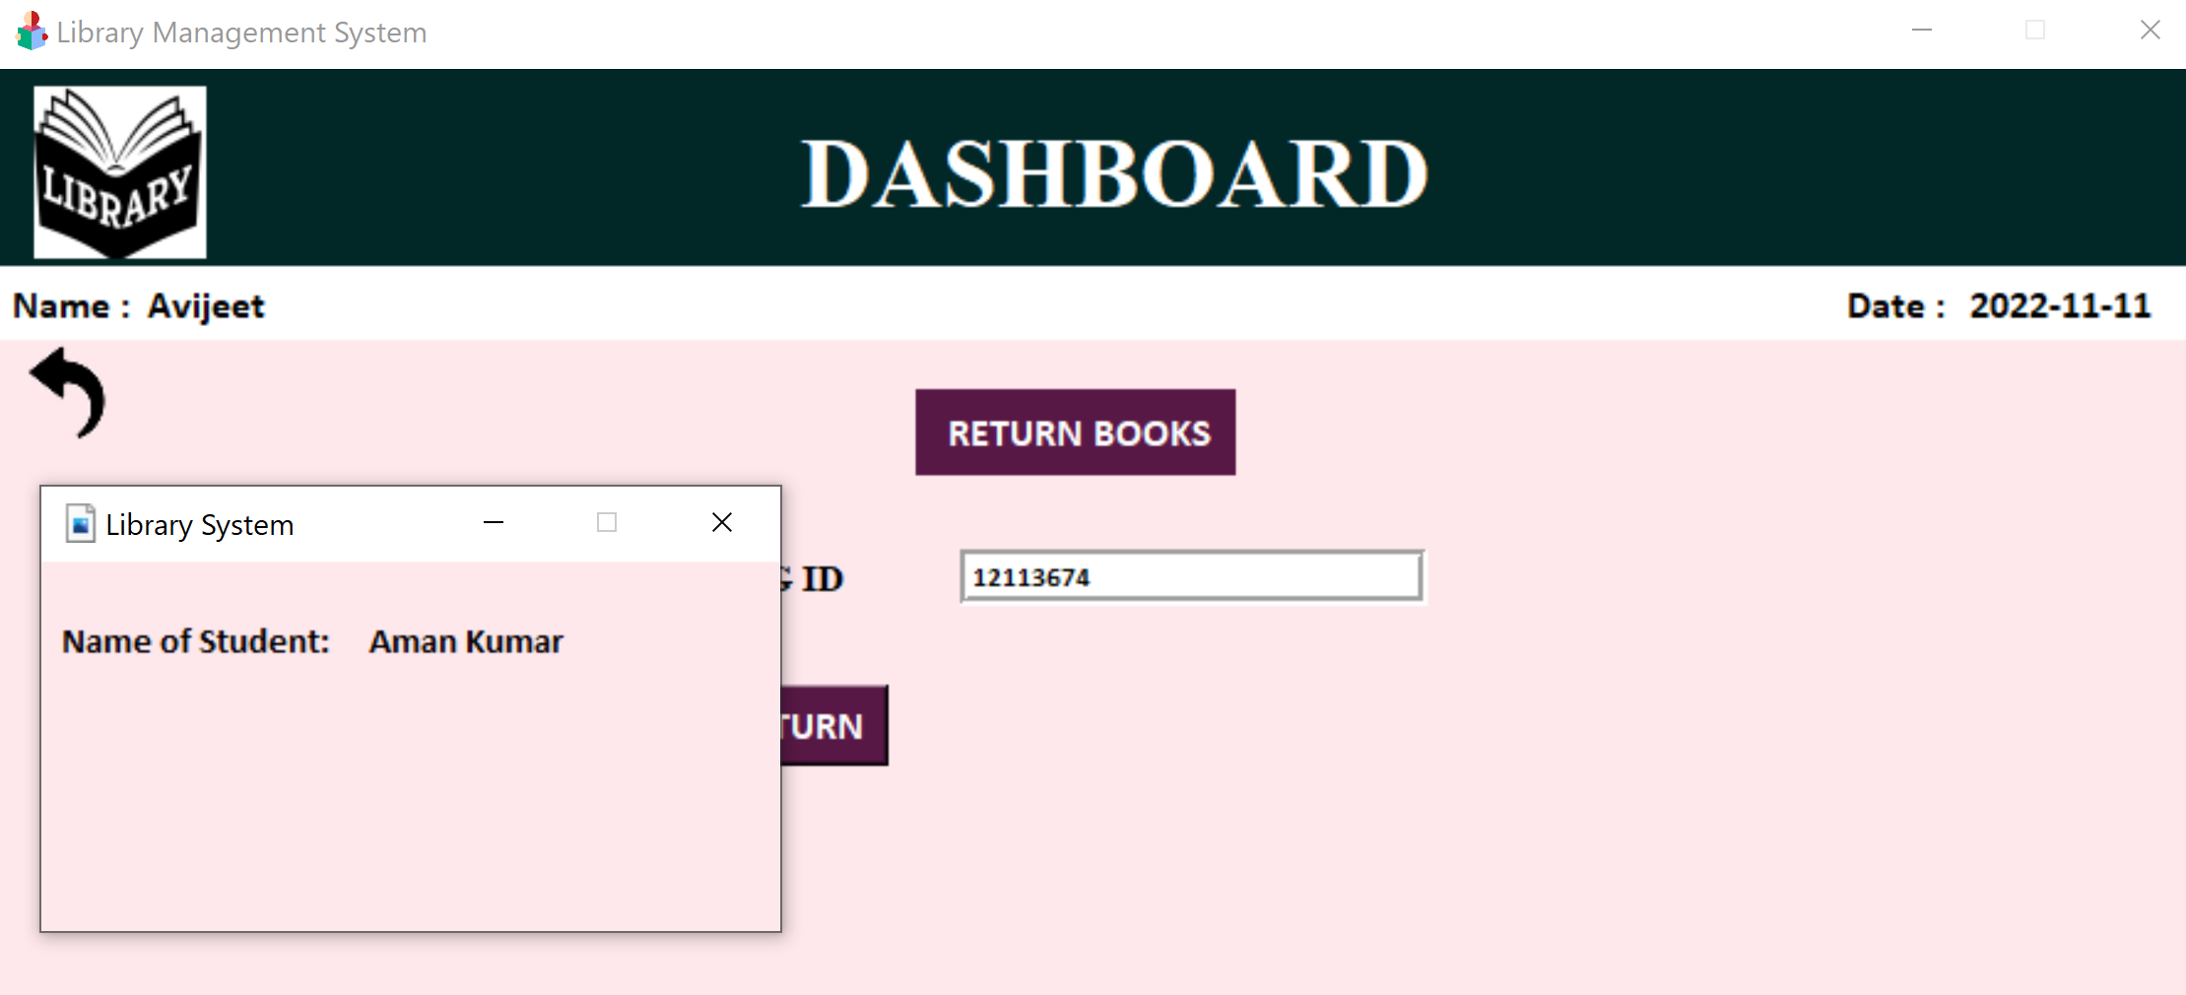

1. **DELETE BOOKS**

* After clicking on return books

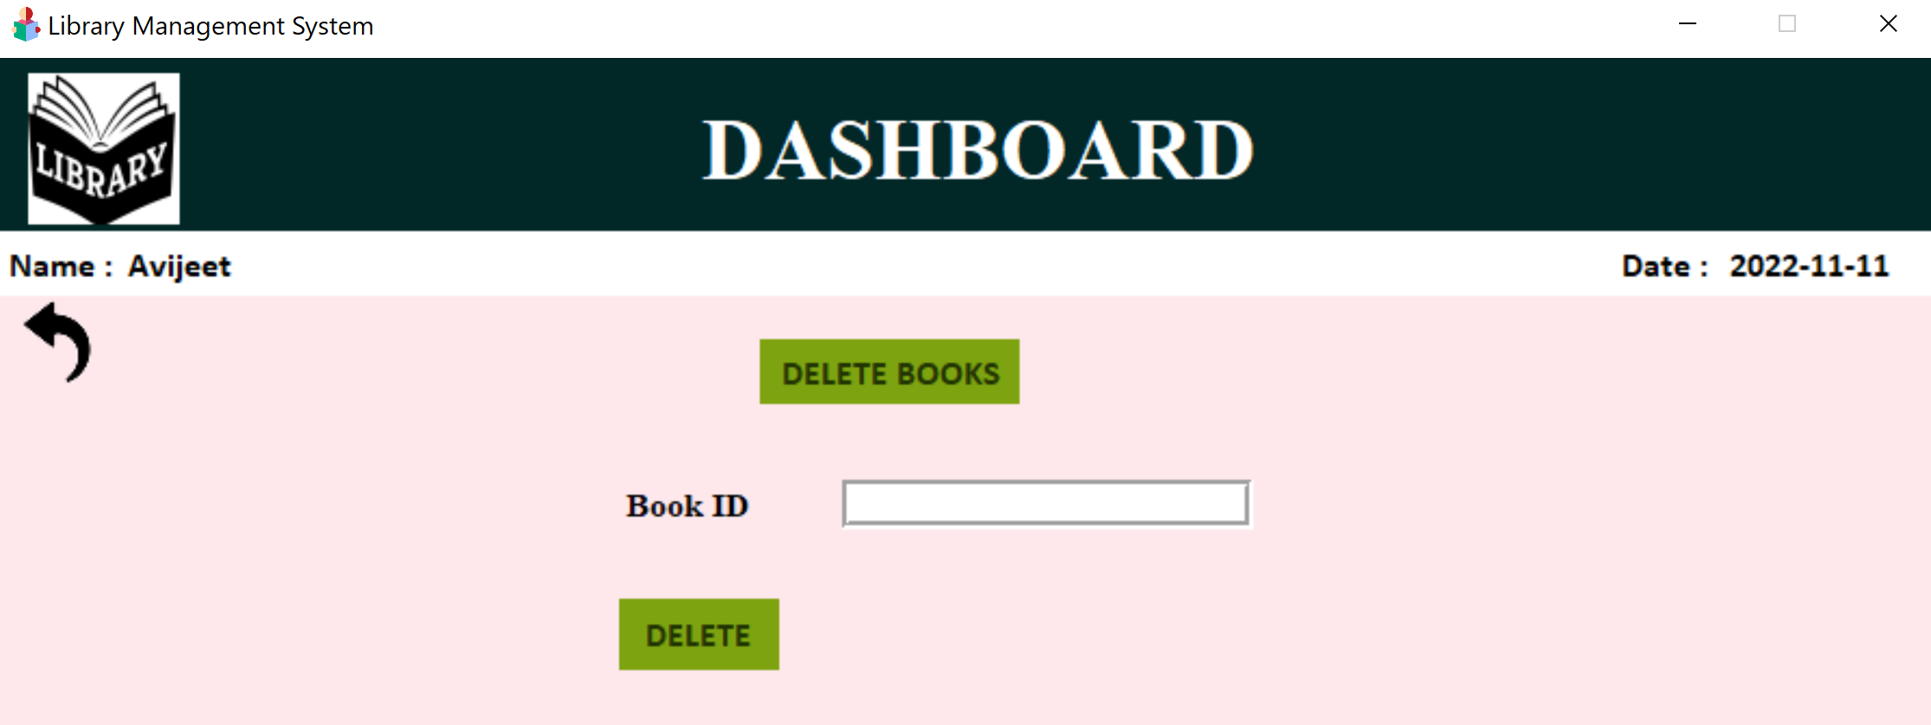

* After entering valid book id, the book’s records shall be deleted and the following pop-up shown.

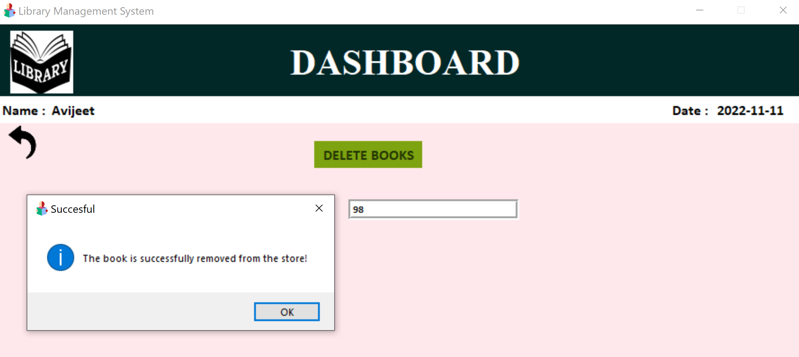

1. **SEARCH BOOKS**

* After clicking on search books

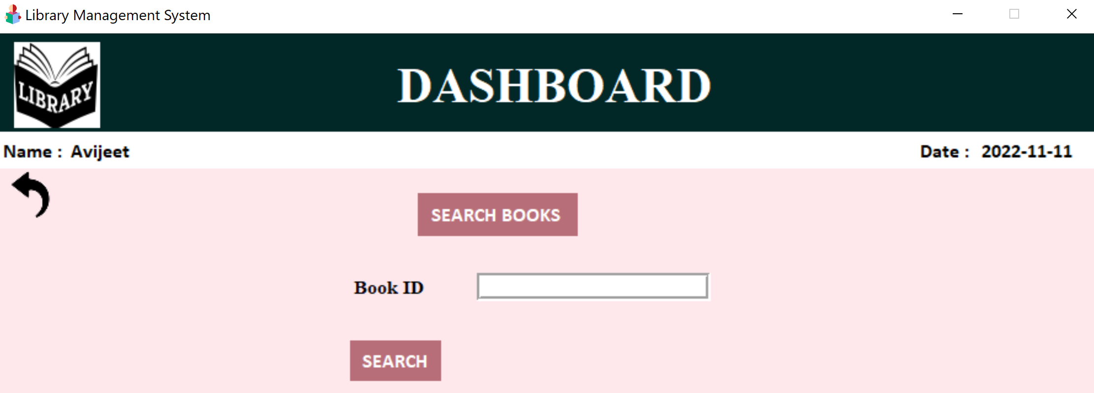

* After entering valid book id

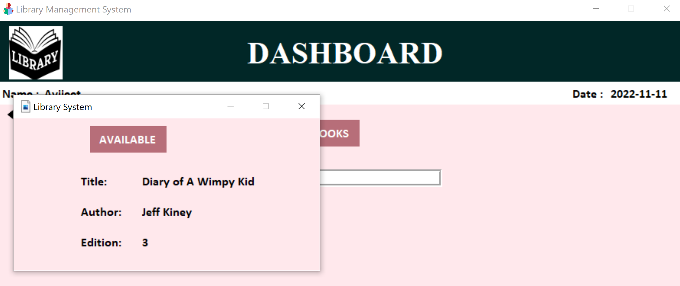

1. **SHOW BOOKS**

* After clicking on show books, all the book in the database will be shown

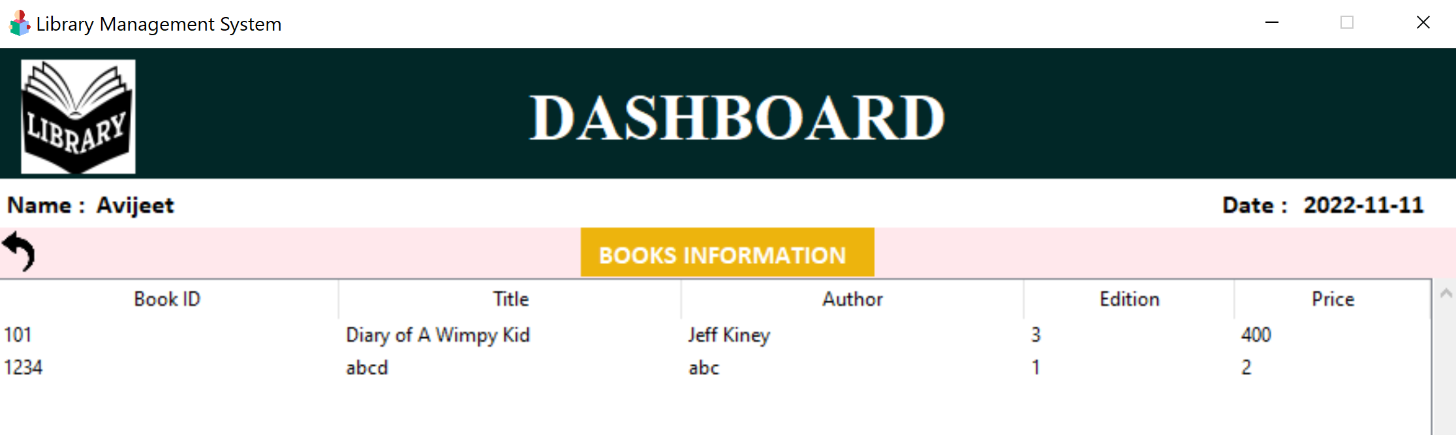

1. **LOG OUT**

* After clicking on the log out button we will return to the login page

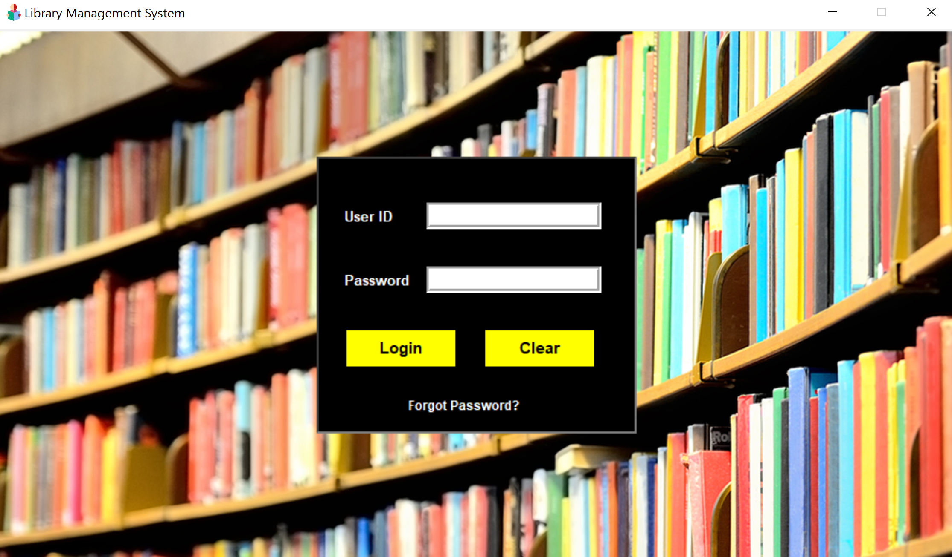

**TABLES USED**

**BOOKS:**

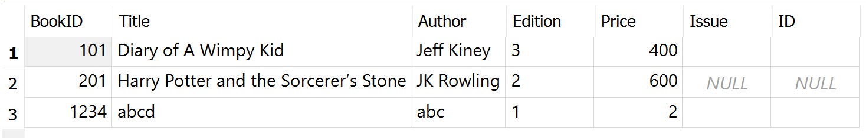

**ADMINS:**

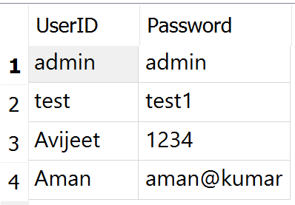

**STUDENTS:**

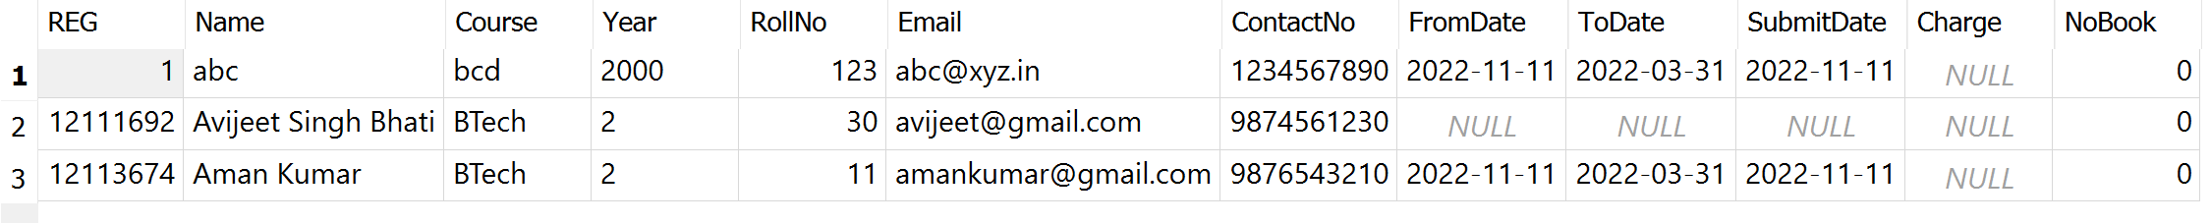

**DATA FLOW DIAGRAM/ FLOWCHART**

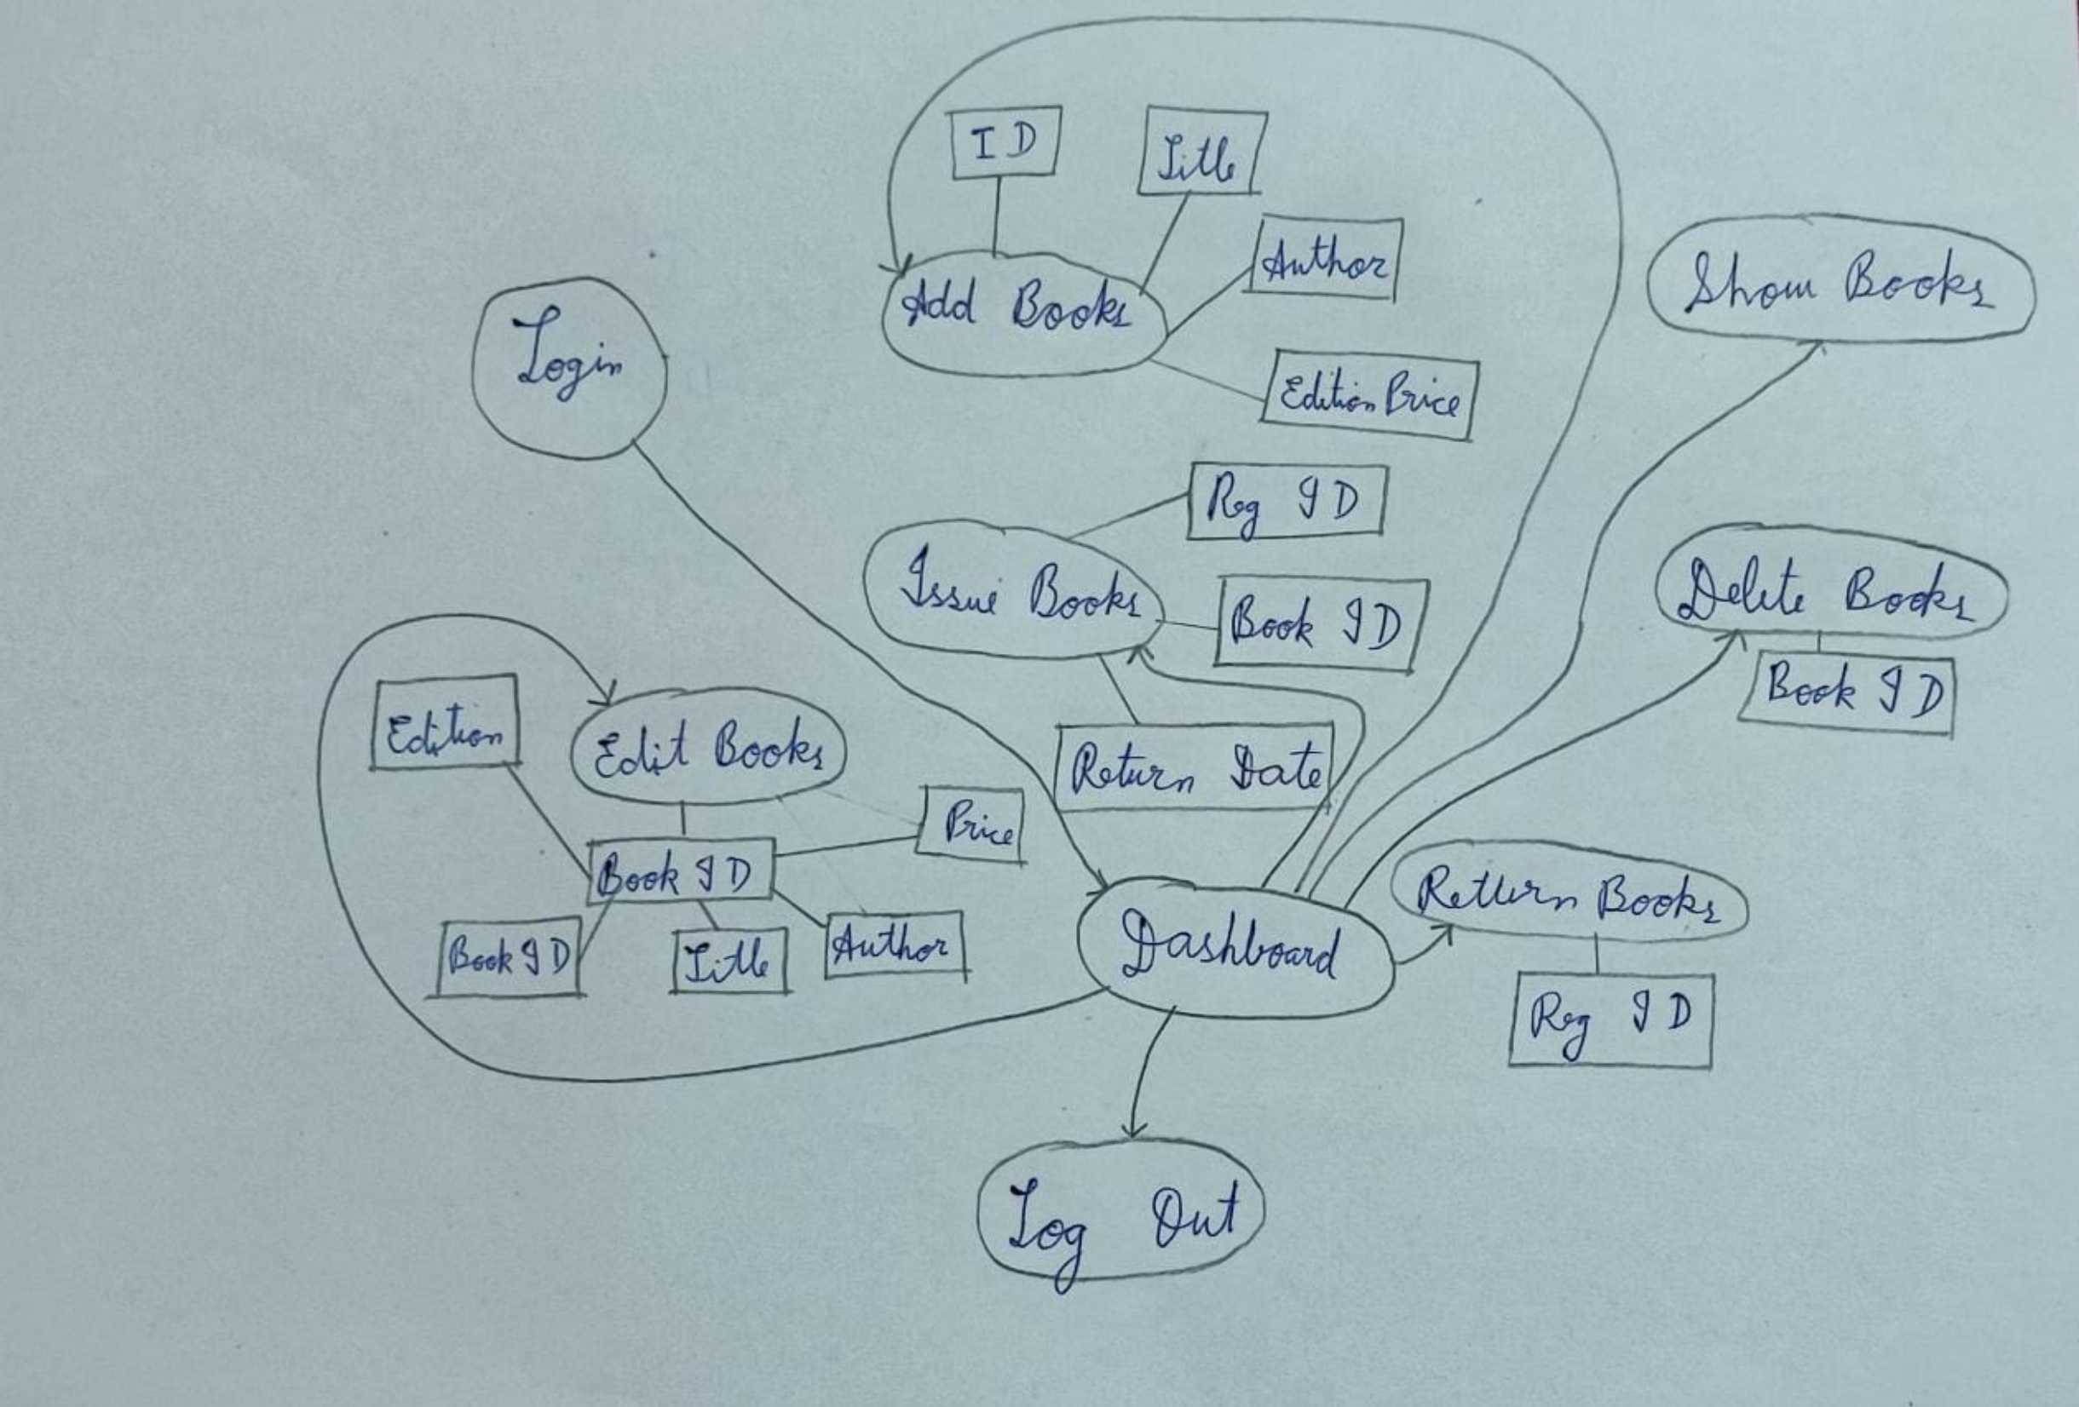

**CONCLUSION**

* We feel that we were successfully able to create a software on Library management system and think that we meet your expectations.
* We tried to keep the software as easy to use as possible as not everybody is technologically very skilful and thus widened our users.
* We believe that this software is good enough to be used at any commercial or public library while keeping the door to updates open.
* This project helped us understand the concepts of Python and how to use GUI with it.
* We learned how to use databases in our applications too.
* We learned the power of Object Oriented Programming and how easy it is once one has the firm grasp on its basic concepts.

**REFERENCES**

* <https://www.geeksforgeeks.org/>
* <https://www.reddit.com/>
* <https://www.quora.com/>
* <https://www.edureka.co/>
* <https://www.tutorialspoint.com/>
* And various projects uploaded online